BOLD Coffee Mug prototype

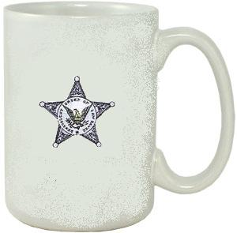

Benevolent Order

of Law Dawgs

Copyright 2005

